# SEL Relay Hardware Wiring

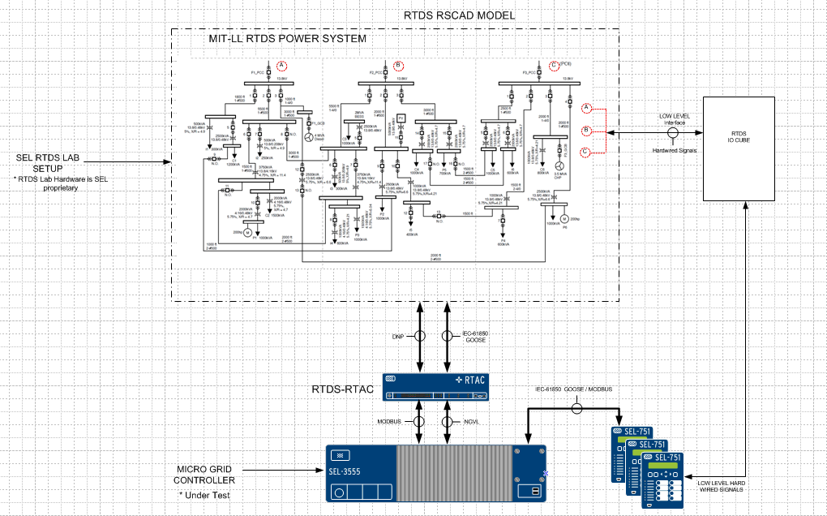

Digital Inputs: Breaker status: 52A/B   
and   
Analog inputs:   
Secondary Currents/Voltage of all phase ( CTR and PTR values required)   
Digital output from the relay: TRIP  and CLOSE